Super.py User Guide

Super.py a command-line tool able to keep track of a supermarket's inventory.

Super.py's main functions are:

* buy
* sell
* report

# Getting Started

Super.py offers a help menu which you can use to learn more about its functionalities. Simply run the --help command as follows:

$ python super.py --help

$ python super.py report –help

# Buying products

To buy merchandise for your supermarket you will be using the buy command, followed by the following information about the products:

* name
* price
* expiration date
* quantity (optional; if not specified, one product will be purchased)

A successful purchase will be followed by a confirmation message. Alternatively, it will be followed by an error.

$ python super.py buy --name broccoli --price 1.2 --expiration 2022-11-30



$ python super.py buy --name tomato --price 1.2 --expiration 2022-11-30 --quantity 50



$ python super.py buy --name tomato --price 1.2 --expiration 2022-08-30



$ python super.py buy --name tomato --price 1.2



# Sell command

To sell merchandise of your supermarket you will be using the sell command, followed by the following information about the products:

* name
* price
* quantity (optional; if not specified, one product will be sold)

A successful sell will be followed by a confirmation message. Alternatively, it will be followed by an error.

$ python super.py sell --name cookie --price 1.25



$ python super.py sell --name apple --price 0.5 --quantity 30



$ python super.py sell --name broccoli --price 1.5 --quantity 5



$ python super.py sell --name cake --price 3.75



$ python super.py sell --name broccoli --price -2



$ python super.py sell --name broccoli



# Report command

The report command will help you get insights on one of the following:

1. Inventory
2. Revenue
3. Profit

## Inventory

To learn more about your inventory, run the report inventory command followed by:

* Date
  + Now
    - will show you only items left in the inventory at the moment of the interrogation
  + Today
    - will show you all the items that have been in today’s inventory, including items already sold on the date; if you would like to exclude those, use *now* instead
  + Yesterday
    - will show you all the items that have been in yesterday’s inventory, including items already sold on the date; if you would like to exclude those, use *today* instead
  + Date (custom date YYYY-MM-DD format)
    - will show you all the items that have been in the specified date’s inventory, including items already sold on the date; if you would like to exclude those, use the next date instead
  + Timeframe (custom timeframe YYYY-MM-DD YYYY-MM-DD format)
    - will show you all the items that have been in the specified timeline’s inventory, including items already sold during the specified period; if you would like to exclude those, use the next date instead
* Export
  + Will make a csv export of your inventory
* Chart
  + Will offer data visualisation

$ python super.py report inventory --now

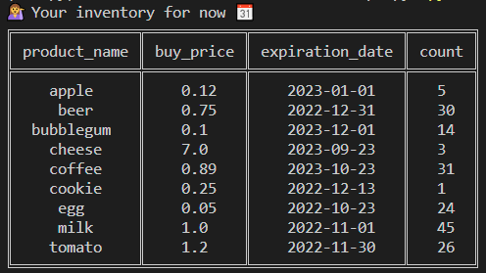

$ python super.py report inventory --now --export



*when queried on the 14th of October 2022

$ python super.py report inventory --now --chart

